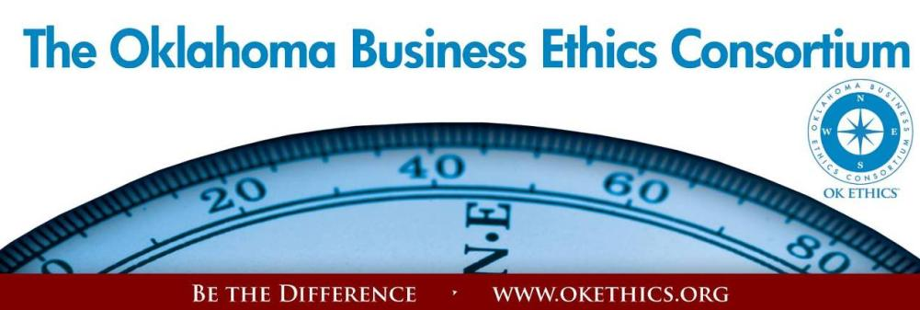
Agenda – November 15, 2012
- Welcome – Garyl Geist, Chief Operating Officer, Oklahoma Asthma & Allergy Clinic;
President, OK Ethics (State) Board of Directors

KICKING OFF OUR TENTH YEAR PROMOTING OKLAHOMA VALUES OF INTEGRITY AT WORK!
VOLUNTEER & MEMBER APPRECIATION HONORS PROGRAM

II. Kudos – Shannon Hiebert, Vice President of Human Resources, Enterprise Holdings;
President, OK Ethics Foundation
● Co-Hosts: Southern Nazarene University Peer Learning Network
● Statewide Student Ethics Champions:
Oklahoma Christian University, 1rst & 3rd place
Advisor: Professor Jeffrey Simmons: Student Spokesperson: Brandon McWaters
Team Members: Genesis Rodriguez, Chas Carter, Austin Hughes,
Hannah Ketring, and Christian Asbill
University of Oklahoma, 2nd place; Advisor: Dr. Steven Ellis
Regional Ethics Bowl to be held in San Antonio this weekend!
Participating Universities: Oklahoma Christian, University of Oklahoma, University of Central Oklahoma, Oklahoma City University, Oklahoma State University
Corporate Judges & Moderators: Shannon Hiebert (Enterprise Holdings); Colin Schoonover, (ONG); Tony Blasier, Jack Rosenthal and David Winfrey (Chesapeake Energy)
Special thanks to Chesapeake and Enterprise for their generous donations as well as OK Ethics Board member Bob Byrne who made a $10,000 contribution last year in memory of his late wife, Jeanne Byrne. We are deeply grateful for their continued support!
- Honors & Appreciation - Garyl Geist, Chief Operating Officer, Oklahoma Asthma & Allergy Clinic;
President, OK Ethics (State) Board of Directors
● OK Ethics Board Member Recognition (See 2013 Member Guide for details.)
● Volunteer Appreciation (See next page of agenda for honorees.)
● OK Ethics Member Appreciation Honors (See 2013 Member Guide for details.)
IV. Upcoming Events - Shannon Warren, Founder, OK Ethics

V. Fish! Book Signing immediately following program; Make $15 checks payable to Southern Nazarene University Bookstore; credit cards accepted, too.
Please be sure to pick up your CPE certificates
at the conclusion of the program. We cannot mail these later.

VOLUNTEER APPRECIATION:
OK Ethics relies primarily on volunteers to achieve the organization’s successful pursuit of Oklahoma’s values of integrity at work. It takes leadership and teamwork to host these exciting events and we salute your dedication in achieving OK Ethics’ mission! Listed below are the regular volunteers who consistently provide service to our members:

Ambassador Team: These friendly people welcome our guests each month and assist in helping them locate seats. They also arrive early to help distribute agendas and assist with name tags.
Linda | Streun | Ideal Homes | Ambassadors - Chair
John | Burnett | Character First | Ambassadors (Lead)
Brent | Martens | Accounting Principals | Ambassadors (Lead)
Connie | Root | Walker Companies | Ambassadors & Recognition Items
Marvinette | Ponder | Devon Energy | Ambassadors & Registration
Chris | Ferguson | Oklahoma Funeral Board | Ambassadors
Jamie | Gorman | Hyde & Company, CPA's | Ambassadors
Scott | Harris | Oklahoma Baptist University | Ambassadors
Wayne | Hart | Legal Shield | Ambassadors
Jenny | Hatton | Boeing | Ambassadors
Valorie | Hodges | Valir Health | Ambassadors
Tammy | McKeever | Enterprise Holdings | Ambassadors
Larry | Musslewhite | Retired (OES) | Ambassadors
Jacob | Pasby | Arnold Oil | Ambassadors
Bobby | Redinger | Cole and Reed | Ambassadors
Bill | Turner | Valir Health | Ambassadors
Brandy | Weldon | SandRidge Energy | Ambassadors
Daniel | Yunker | Kimray, Inc. | Ambassadors
Nancy | Hyde | Hyde & Company, CPA's | Ambassador - Executive Team
Tom | Shehan | Nextep, Inc. | Ambassador - Executive Team
Registration Team: These dependable individuals show up every month to diligently record our guests’ attendance and handle the collection of fees:
Mark | Neumeister | D.R. Payne | Registration - Chairperson & Tax Advisor
Joe | Walker | Arledge & Associates | Guest Registration (Prepaid Chair)
Mary Kay | Huggard | Principal Technologies Inc. | Guest Registration
Mary | Vaughan | Mary Vaughan, CPA | Guest Registration

Agendas: These volunteers have done a remarkable job in ensuring we have colorful agendas at every event!
Cheryl | Campbell | Metro Technology Centers | Agendas
Kyle | Gaines | Metro Technology Centers | Agendas
Trish | Potter | Metro Technology Centers | Agendas
Bertha | Robinson | Metro Technology Centers | Agendas
Nina | Truitt | Metro Technology Centers | Agendas
Lynn | Willis | Metro Technology Centers | Agendas

Special Initiatives:
Susan | Pate | Stinnett & Associates | Accountant
Connie | Rutz | Maximum Multi Media | AV & Media
Michael | Mount | Oklahoma Accountancy Board | CPE's
Jamie | Potter | Eide Bailly LLC | Facilities & Logistics Chair
Bill | Blew | The Olive Branch | Peacemaker Facilitator
Jalisha | Petties | OK Ethics | Member Care Coordinator
Anna | Rosenthal | OK Ethics | Special Projects & Name Tags

Member Appreciation:
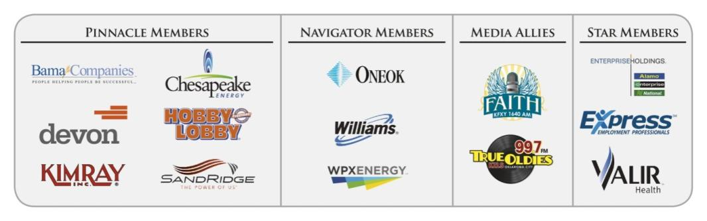

Please refer to your Member Guide 2013 for a more detailed listing of our members. We appreciate all that our contributors do to promote business ethics in our Oklahoma communities. Their support resulted in the following achievements last year:
- An average of 450 business leaders and professionals in attendance at monthly programs focused entirely on business ethics. That’s an increase of nearly 100 participants this past year!
- Thanks to you, we are now able to bring in internationally-known speakers, in addition to programs presented by local heroes. This past year, we welcomed leaders such as Chuck Colson and General Tommy Franks. Our annual Compass Award was the largest ever and featured the renowned business leader, consultant and author Stephen M. R. Covey. It was a major milestone for us!
In November, we will kick off a year-long celebration toward our tenth anniversary with keynote speaker, Harry Paul. He is one of the authors for the best-selling book, Fish! In December, we will welcome the former CEO of Saab and author of Love Works, Joel Manby. (You might have heard of him as he was featured on the hit television series, Undercover Boss.)
- This year, we found it necessary to retain some part-time workers, but most of our work continues to be performed by a dedicated group of volunteers. By spreading the work among these passionate individuals, we are able to maintain the lowest possible overhead while continuing to deliver valuable services to our business community. The ROI is significant as we provide numerous continuing education programs that are consistently high in quality.

- Finally, our outreach to university students has greatly increased. Part of your membership dues are earmarked to sponsor student ethics activities on thirteen Oklahoma campuses and our Foundation recently sponsored a Statewide Educators Ethics Symposium that was attended by approximately 70 academic leaders representing nearly 20 educational institutions.
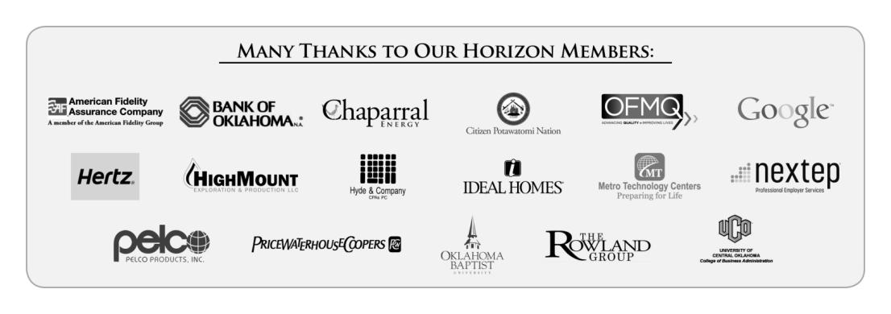
- Upcoming Events: Oklahoma City Chapter Shannon Warren, Founder, OK Ethics
TUNE IN! Our own Bob Byrne and Shirley Mears featured on the morning drive for True Oldies Channel FM 99.7 – Tune in between 7:00 and 8:00 a.m. to learn more about Oklahoma’s legacy! Also, hear interviews with speakers thanks to Champlin Broadcasting!

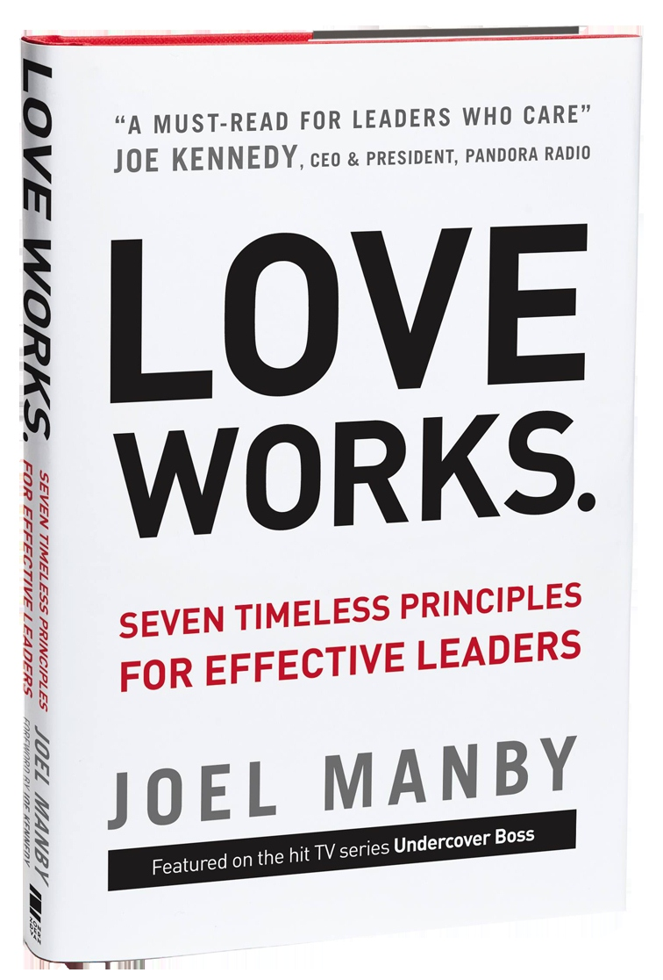
NOTE DATE CHANGE: Friday, December 7 at The Petroleum Club

Joel Manby, President and CEO, Herschend Family Entertainment Corporation,

You may have heard of Mr. Manby because he starred on the
CBS hit show Undercover Boss.
Manby and the employees of HFE moved millions of viewers across the world with their unique approach to leadership. He now shares the principles that make HFE successful in his new book, Love Works.

Manby has incorporated the definition of love the verb into the company’s existing organic culture to establish how leaders are to behave. He views love as a mode of thinking – one that has helped him deliver tangible results and position his company as the 9th largest themed attractions company in the world.

An expert on leadership and customer relations, he spent 20 years in the auto industry. Manby was a member of the start-up team for Saturn Corporation, followed by a successful career as CEO of Saab Automobile USA where sales increased by 67% and their J.D. Power Quality Rating improved from 30th to fifth in the industry.
Many thanks to our friends at Strata Leadership for making this happen!

Help spread the word:
Please post Upcoming Events on your company’s bulletin board.
Wednesday, January 9, 2013  Petroleum Club – OKC | Wednesday, February 13, 2012  Petroleum Club - OKC
“Overcoming Contention  and Divisiveness”  presented by  Wes Lane  Former OKC District Attorney and  President, Salt and Light Leadership Training, Inc.  Introduction by current OKC District Attorney, David Prater | “What in the World is Going On?”  presented by  Lori Tansey Martens  President & Founder,  International Business Ethics Institute  Washington D.C.
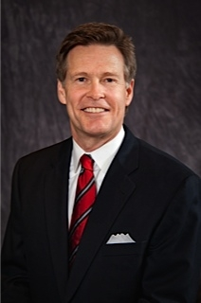 | 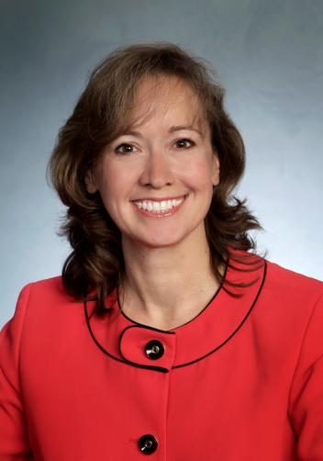

Conflict happens. It is simply a natural part of life, whether at home, the workplace or in the community. Conflict can be healthy process as long as participants believe they can trust one another. In fact, the ability to resolve conflict with integrity is likely to make our relationships stronger. We don’t have to agree with one another, we simply need to show genuine trust and respect. Our group of professional panelists will provide real life examples for resolving conflicts while maintaining integrity.
TULSA CHAPTER ACTIVITIES:
Thursday, November 29
"Ethical Solutions to Conflict: Why Can't We Get Along?"
panel presentation by:
Melissa Clark, APR, WPX Energy
Gary Richetto, PhD, Triad Associates
Councilor, G.T. Bynum, Tulsa District 9
Kevin Kennemer, SPHR, The People Group

Programs Focused on Integrity - (Not affiliated with OK Ethics)

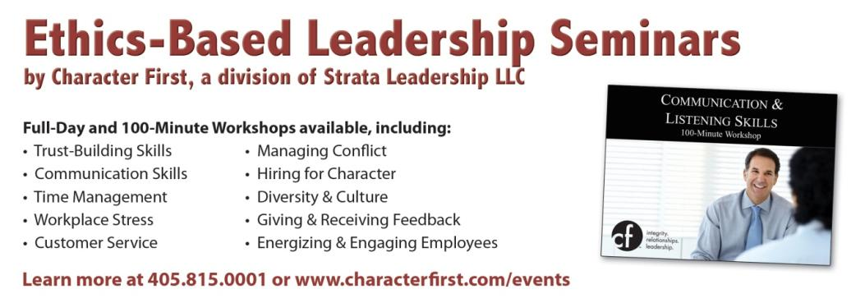
Since the beginning, OK Ethics members have been inspired by our friendship with Character First. Leaders with this organization provided the wisdom and insight for OK Ethic's Guiding Principles. Go to www.characterfirst.com to learn more about tools to help you integrate character and ethics into your organizational culture, or contact John Burnett at 405-815-0001

Character Council of Central Oklahoma …cultivating good character

The Character Council of Central Oklahoma is an organization that educates, equips and empowers others to create a culture of good character within Central Oklahoma. Their vision is that Central Oklahoma will become a model community of good character.
Friday, November 16
Cost is $20 per person; Reservations made via luncheon@characterok.org

Interested in Receiving OK Ethics Monthly Meeting Notices?

OKC:
Contact Jalisha Petties, Member Care Coordinator
at (405) 889-0498 or via email okethics@yahoo.com

Interested in joining OK Ethics?

Contact Lynda Mobley, Vice President of Membership
Lynda.Mobley@oneok.com

LIKE OKETHICS ON FACEBOOK


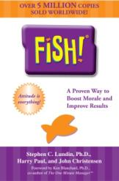
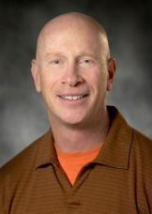
"Fish! and The Power of Ethics"
Work Made Fun Gets Done!

A Foundation of Commitment, Common Sense and Integrity
It's not about deciding what is right, it's about doing what is right.

presented by
Harry Paul, co-author Fish!

Harry Paul Biography
With a Ph.D. in experience, Harry has over 30 years in business including running all aspects of a management training and consulting business, including sales, distribution, product development and international operations. He has served as a senior vice president for The Ken Blanchard Companies, where he personally managed the speaking career of Dr. Kenneth Blanchard, co-author of The One Minute Manager.
Known as Harry the Fish! Guy, he co-authored the best-selling book that creates fun at work while maintaining one’s integrity. Prior to the release of that book, Harry worked with Ken Blanchard and collaborated with Norman Vincent Peale on the launch of the book, The Power of Ethical Management.

Harry is co-author of six books including the internationally best selling business book FISH! A Proven Way to Boost Morale and Improve Results. FISH! has been on the best seller lists of: The New York Times, The Wall Street Journal, USA Today, Business Week, Amazon.com and Publisher’s Weekly and is one of the best selling business books of all time.
Harry brings the messages in his books to life in each of his presentations, sharing his message with hundreds of organizations motivating and exciting audiences worldwide about going to work and working hard; where their decisions are based on the mission, vision, and values of the organization. You will leave this session feeling invigorated and inspired!
Program Notes:

Recommended for CPE in Ethics at the basic level. Program is suitable for any business leader desiring to promote integrity in the workplace. See program description below for more information about learning objectives.

Choosing Your Attitude
An Attitude Based on Purpose
What you do is too important not to make the
right decisions
Play
Keep work lighthearted to avoid creating a toxic environment
Work made fun gets done
Malicious Compliance

(Continued on next page)

Be There
Have the right Perspective for doing what’s right.
Ethics check
Observe from the other side:
Is it fair, balanced and legal?
Think like you are on the receiving end:
Are you proud of your decision?
Act like you own the decision:
You do. How will it make you feel—
especially as others know?

Make Their Day
Be consistent and persistent in all your interactions
People are constantly counting on you to do the right thing
Key Take-Aways:
- Learn to use the 3 P’s of Ethical Management

- Learn to double check with the Ethics Check

- Learn the four B’s of trust

General Program Disclaimer:
Members of the Oklahoma Business Ethics Consortium frequently share information concerning various issues and developments that may have legal implications. The discussions, commentary, and handouts at Consortium meetings or presentations to other organizations are for general informational purposes only. They cover only some aspects of the subject topic, and do not constitute a complete legal analysis of the topic or how it might apply to any particular set of facts. Before taking any action based on information presented during a Consortium event, participants are encouraged to consult a qualified attorney. The observations and comments of presenters at Consortium meetings and networking are the views and opinions of the presenter and do not constitute the opinion or policies of the Consortium or any of its members. Presenters are respectfully requested to avoid profanity, preaching, politics, put-downs and self-promotion during their lectures

REMINDER: PLEASE PICK UP CPE’S
AT CONCLUSION OF EVENT.

